

Electronic Signature for Financial Responsibility Agreement
Step 1: Login to Ellucian Self-Service and click on your username to show the drop-down menu.
Step 2: Click “Required Agreements” to bring the Financial Responsibility Agreement form up.
Your User
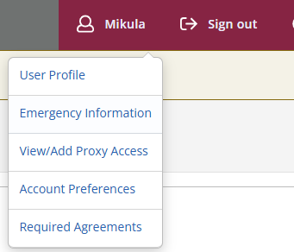

Step 3: Click view to view, read, and sign the agreement.

Step 4: After reviewing and reading the agreement, click accept at the bottom.

